API Catalogue: Add Comments

By Sarah Wade
Software Developer Level 4
BGL Group

Contents Page

2. Project Background
2.1 Ways of Working
2.2 Technologies Used
2.3 People Involved
4. Design Phase
8. Coding Phase
13. Back End Development
17. Deployment and Testing Phase
22. Conclusion
24. Deleting Comments

Project Background
I am currently placed as an Apprentice Junior Software Engineer on the ‘Techinators’ team at my workplace, BGL group. My team’s responsibility revolves around improving internal software and migrating existing programs to updated versions (e.g. mule 3 to 4). For this piece of work, I was assigned to add additional functionality to an existing program called the ‘Api Catalogue’.

Ways of Working

My team operates through Agile principles. During this project, I worked during a two-week sprint and attended stand-ups, retros and sprint planning meetings.
As part of my company’s SDLC I would be keeping in regular contact with the product owner each morning during the stand-up, and with live demos throughout the sprint. With regular feedback from the product owner at each stage this would guide the work completed to ensure it completely meets the requirements.
My company required each piece of work to be approved by the product owner, and my code would need to pass a pull request before being merged into live. This would be completed through my company’s source control, bitbucket, which I would be pushing my code to regularly via git extensions. The pull request once reviewed would ensure my code meets the standards Bgl set. Some of the conventions for example, are:
- camelCase for classes
- database headings to have initial letter capitalized
- spaces for indentation, not tabs
- no comments, code must be clear enough to understand without them
- meaningful class/ function names
- single responsibility
- all code to be pushed to a separate branch in the repository

Technologies Used:

During this sprint, I used the following technologies:
- Microsoft XD Studio: For designing prototype design
- Chrome, chrome developer tools: Live testing / de-bugging
- Visual Studio Code: main code development
- Jira: ticket management, tracking of progress
- Bitbucket: code repository, source control
- Git extensions: source control

People Involved:

- Product Owner: Alex, Lead Software Engineer
- Team Leader: Kim, Change Delivery Manager
- Code Reviewer: Josh, Lead Software Engineer

Design Phase:

I attended a sprint planning meeting with the product owner of a piece of software called ‘Api Catalogue’. In a high level, this piece of internal software enables users to view the status and structure of internal company Api’s and follow the flow to their endpoints.
My ticket was to work on the ‘Api Catalogue’ and add an additional feature. This feature was to be a user-interface that enabled users to add comments onto specific API’s and allow others to view the comments. There were several additional user cases such as the comment interface would need somewhere to enter a username and space to write a 255-character comment which would then be saved to a database. I began by speaking to the product owner and team lead, to establish exactly what the requirements for this piece of work were. From this meeting, I identified several high-level business requirements which would act as my user cases:
The end-product needed to:
- Allow users to add comments to specific Api’s
- Allow users to view previous comments
- Have a character limit of 255, as per the product owners request
- Save a username with each comment
- Save the time/date of each comment
Once these were established I created a ticket with my team. As a team, we completed a refinement and discussed what the basic mvp would be and what would be ‘nice to have’. It was decided that the MVP would include the user adding a comment and being able to view the comments on the same page as the intended api view. With this decided we moved onto additional requirements. I contributed my opinion and discussed having ‘deleting a comment’ at mvp, something that had not been mentioned before. I made the point that the overall quality of the product required people to take down comments that were no longer useful or serving a purpose. My colleague made a counter opinion that the comments history should always be available so that previous problems and solutions could be easily viewed.
Together as a team we discussed instead having a ‘edit’ function to enable this functionality. This function would allow user to add onto existing comments, enabling them to be updated with information as the circumstances change. In addition to this, I also decided to add a ticket to enable deleting a comment, so that if editing was not required or a mistake was made the comment could be removed.
With the requirements finalised in refinement I split the work into multiple tickets with clear outcomes directly linked to the original requirements. In figure 1 you can see the created ticket flow:
Fig.1: Ticket Flow
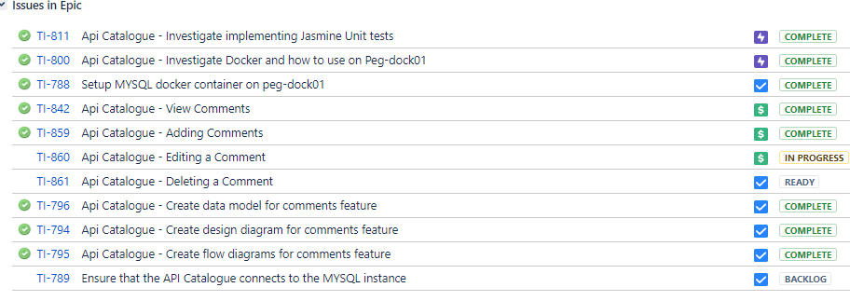
I was assigned the ‘adding comments’ tickets which included creating the user interface for actually adding the comment, creating the backend functions to save the comment to a database and to finally test the feature. I updated the adding comment ticket to include the specific tasks that would need to be completed in order to meet the requirements (see fig.2).
Fig.2: Adding Comments Story
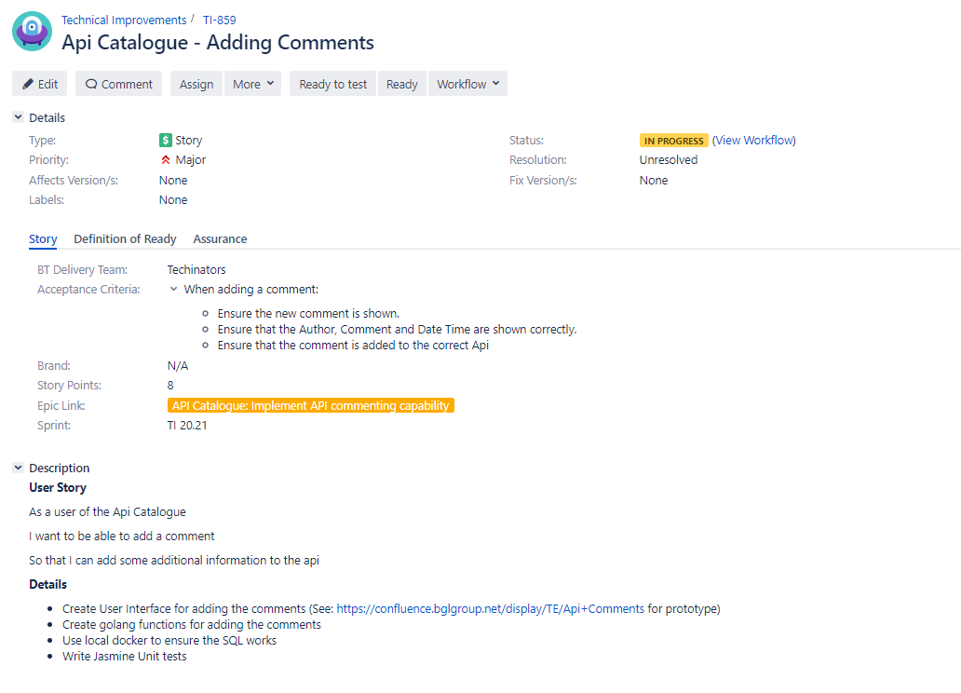

Now that the requirements had been refined I had an idea of how the feature would function and thus was able to begin creating a software design with a supporting confluence page.
From this brief, I used adobe XD to mock up a prototype of the adding comments feature. It needed to adhere to the same styling as the comments history view so I collaborated with the developer working on the other ticket. After creating a basic prototype, I trialled the user journey to making a comment and sought feedback. I implemented the feedback and then trialled different models and designs of the user interface to find the best solution for the user’s needs. After receiving feed-back I updated the editing button to an icon and spaced out the two comments boxes a little more to make it easier to read. The final design can be seen in fig 3. 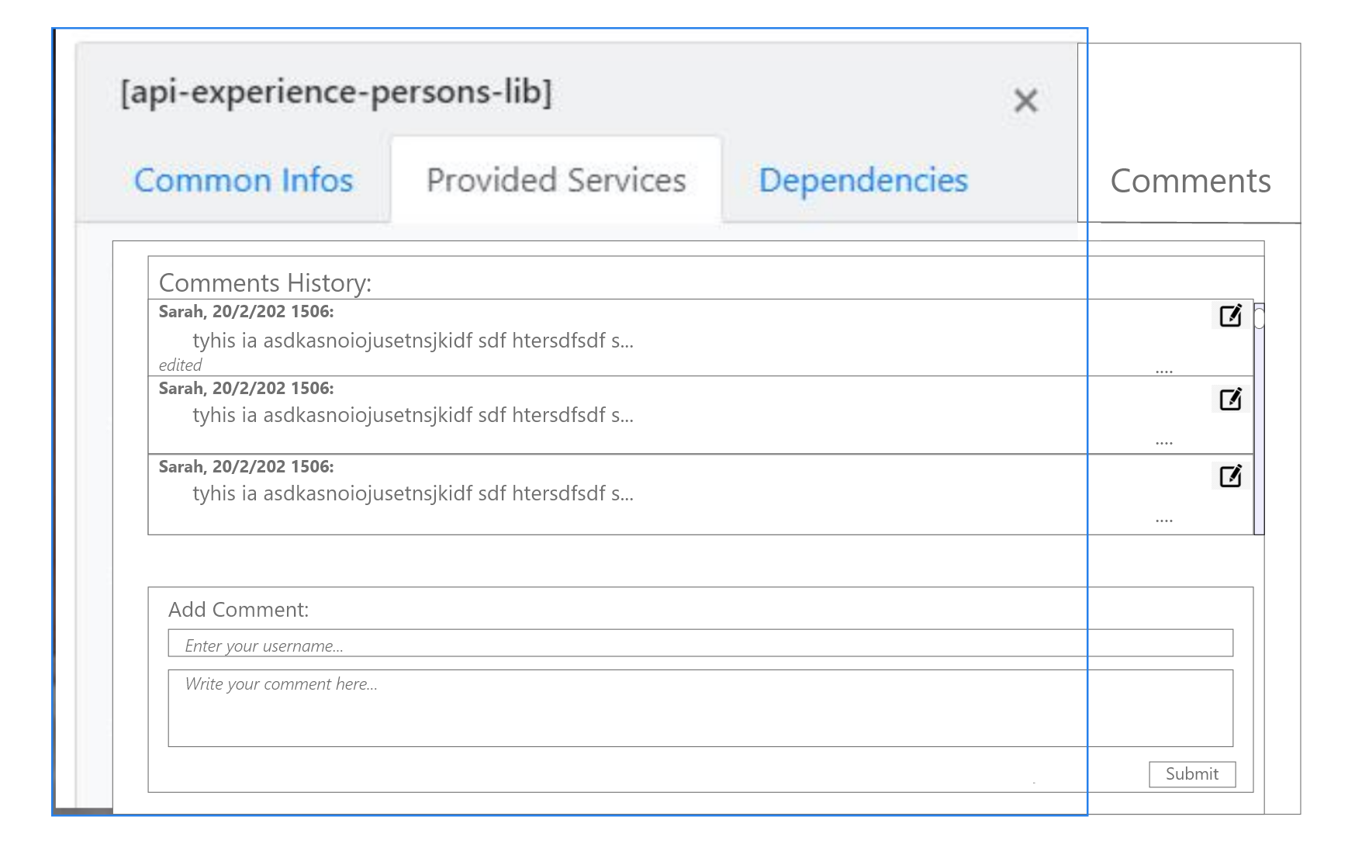
Fig.3: Final Design
This design met the criteria outlined in refinement and included a tidy interface that was clear and easy to understand. Placeholders would be used to prevent confusion as to where the comment needed to be entered.

Based on the successful prototype I created and updated the ticket confluence page with the proposed designs (fig. 4).
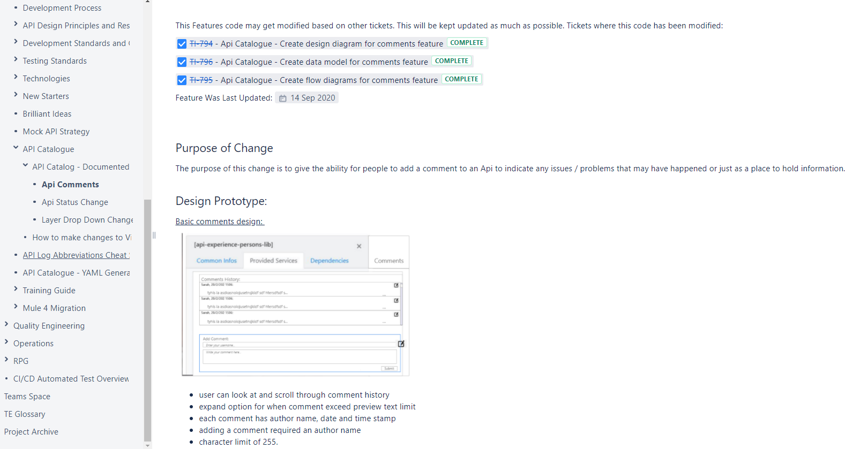
Fig.4: Confluence Page Updated
Updating the confluence page is an importance aspect of future feature support for my company, and ensures knowledge sharing within the greater team.
I created a flow diagram displaying the user journey/ system interaction for each major feature of adding comments and updated these on the confluence page to support knowledge sharing and understanding of the process. For reference, I have also created a class diagram for the comment class and the comment manager class:
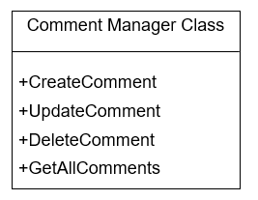
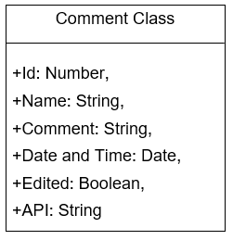

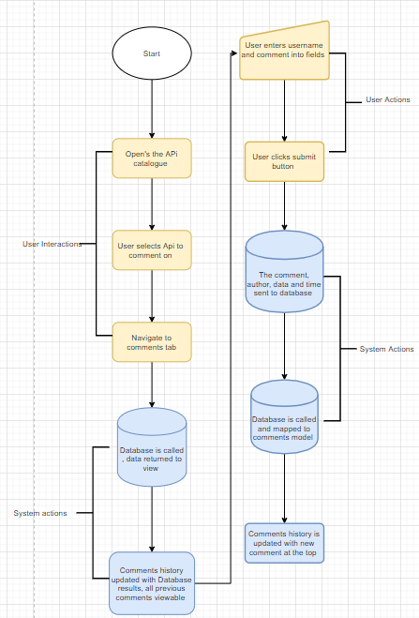
Fig.5 Adding a comment process

I clarified that the end design would meet the user criteria and once satisfied began working on implementing the code.

Coding Phase

During this stage of development, I aimed to progress the main bulk of the front end work for this ticket and complete any setup required. When this feature is deployed it would be accessing a SQL database based on a docker container. In order to work on and test this feature I had to replicate the same settings locally on my machine.
I began by setting up docker container on my local machine and setup phpmyadmin(fig 6).
Fig.6: Setting up docker with PhpMyAdmin

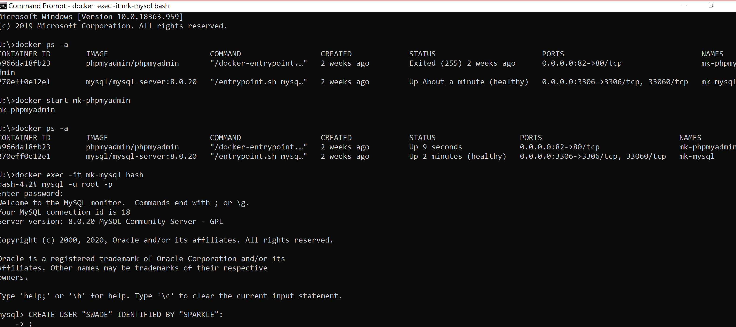I then used docker and phpmyadmin to create an SQL database (fig 7).
Fig.7: MySql container
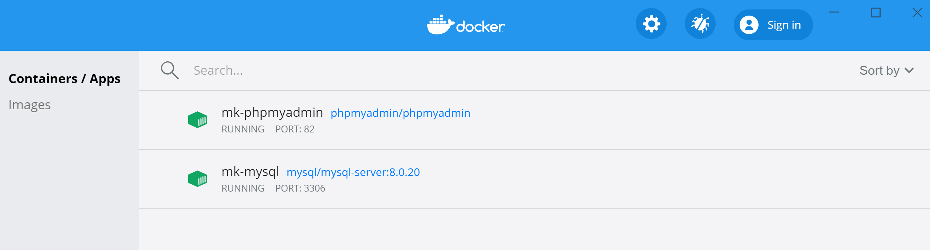

Within phpmyadmin I then created table columns that matched the pre-defined column names and tags from the live docker container setup, ensuring the casing and text format met BGL best practise for readability (fig .8). In BGL there are strict standards to ensure code is readable and clear. After my work is completed I will submitting a pull request where a more senior member of my team (Josh, technical lead) would check to ensure these standards are met. In this case all database variables need to have capitals as the first letter( Fig.8), all javascript classes needed to be in camel case. In addition, all code written needed to align with ‘Solid’ principles too.

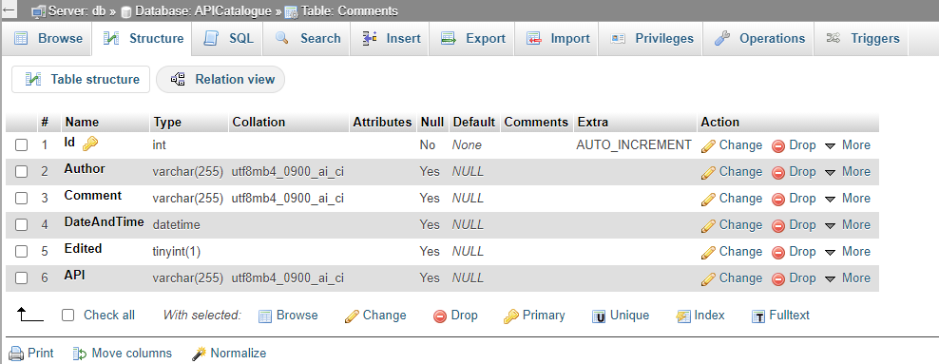
Fig.8: Database table

I decided to work on the front end of this ticket next, hooking in the SQL database at a later date. This would involve creating the basic interface for a user to interact with. There was already a comments history tab added onto the feature page, so my job was to implement the adding comments box beneath it in line with the designs made previously.

I began by using HTML, CSS and Jquery to create the comments box. The first step was to create a basic container for the comments. I primarily used just html and CSS to create this, and inheriting relevant styles from the parent (comments history box) to ensure the appearance remained consistent (fig 9).
Fig.9: UI front end code
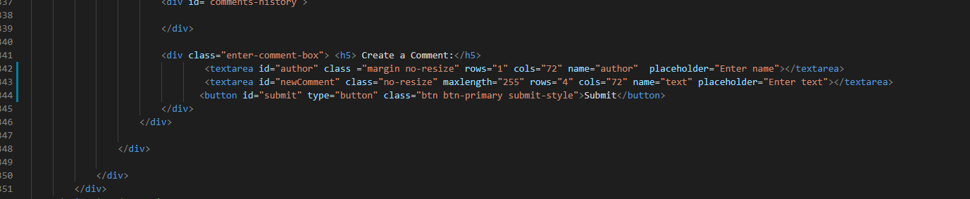
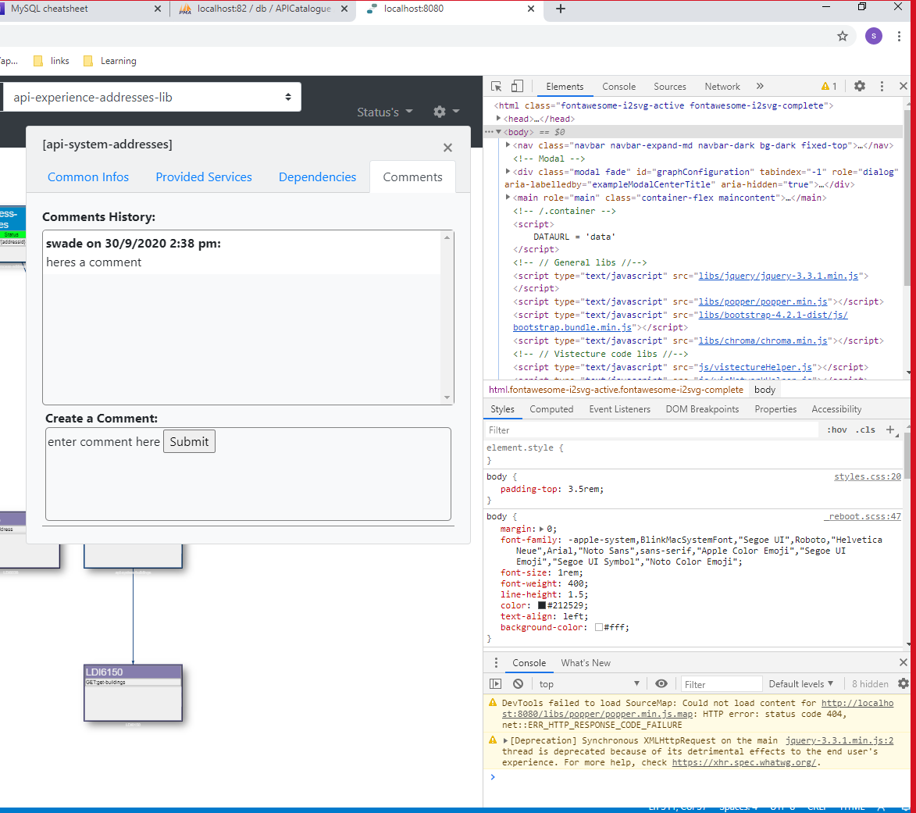
Unlike each individual comment the adding comments box could be implemented statically and as such I used the same margin and text-style settings as the comment history box. I put these in their own individual CSS classes to be built upon later, using inherit where appropriate. I did have to add some height to the overall comments tab container as it was not large enough to encompass the two other containers. I used ‘inspect’ in chrome(fig 10) and edited the styles (fig 11) in the editor until I found a height that would work. I then copied the settings over to the CSS classes and ran the program to visually check it rendered correctly.
Fig.10: Using inspect
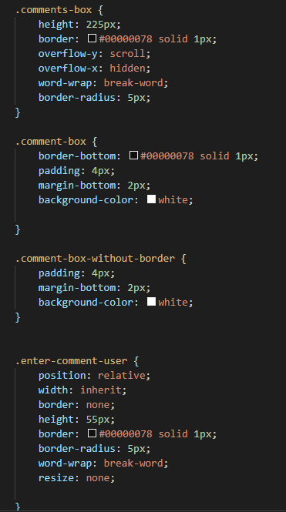
Fig.11: Sample CSS

As displayed in the above screenshot (fig 10) in this case the submit button was still misaligned at this point so I made it my next task to persuade it to sit in the correct position. Again, I focused on using the inspect tool to problem solve and alter elements until I got the desired outcome. After I fixed the box positioning I requested feedback on the current styles. The product owner requested a bootstrap button to match the ones on other pages in the Api Catalogue, which I implemented by using bootstrap snippets (fig 12).
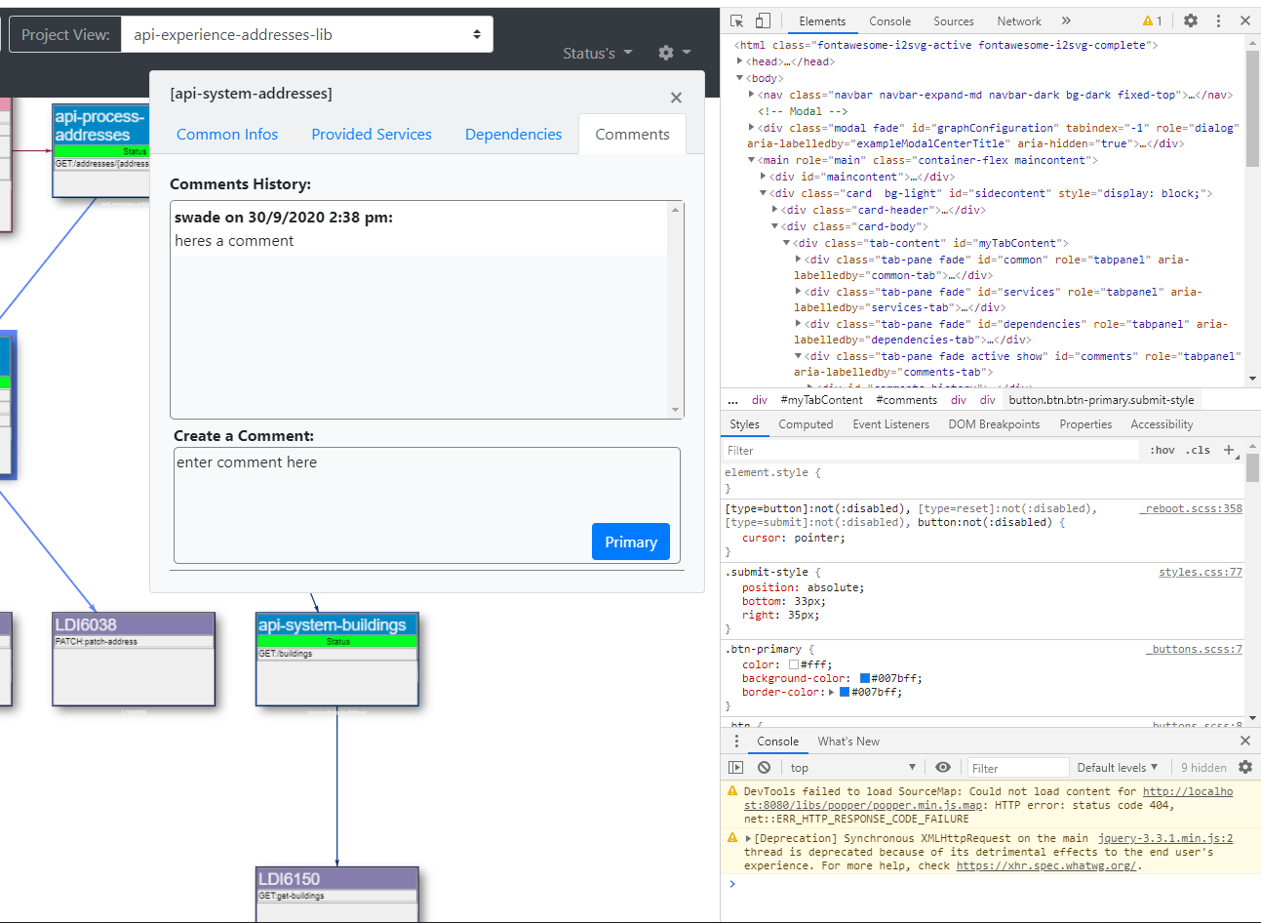
Fig.12: New bootstrap button

My next step was to implement the form itself. For this I used a textarea (fig 13). Using the textarea allowed for the maximum character limit requirement to be implemented, thus meeting the ticket specifications. I used the text area row count to adjust how many lines of text were displayed to avoid unsightly scroll bars being used automatically. Finally, I added a placeholder and an ‘Id’ to use when interacting with backend code.
Fig.13: TextArea with placeholder
At this point I referred back to the specific tasks outlined in my ticket, to ensure I was still conforming to the original user requirements. Satisfied, I contacted the product owner and received final feedback on the user interface which was confirmed as meeting the requirements.
During this phase of development, I created the main front end section of this ticket. I completed numerous activity flow and feedback cycles to ensure that the end product would firstly meet the user requirements and secondly that the final product would be good quality, meeting the business’s needs.
I had to make a few changes during development to better meet the needs of the user and the requirement set out by the product owner. Implementing a specific number of rows prevented the user from experiencing a frustrating ‘miniature scrollbar’ if their comment met the full 255-character limit, something that in testing caused a slightly negative experience. This did mean the entire comments tab was eventually larger than originally planned, however as ethically it still matched the existing styles. The outcome met all the specification’s set out by the product owner as it enabled a user to enter their name and enter a comment of 255 characters (fig 14).
Fig.14: Comments front end
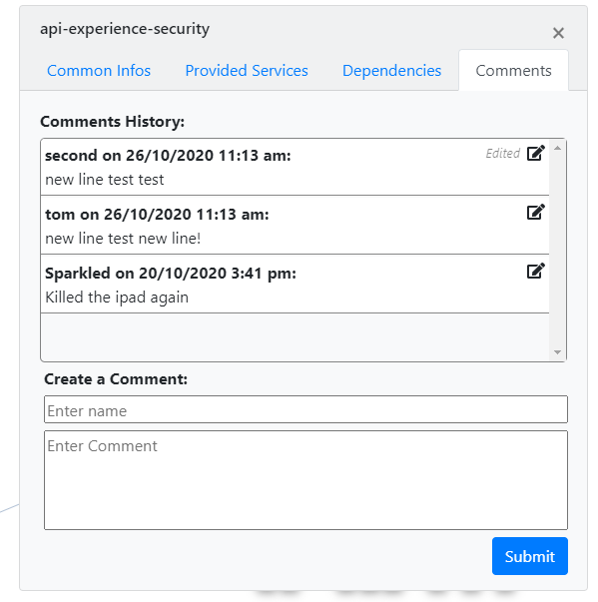

Back end development

The next task was to enable users to enter a comment using the created form and view their comment in the comment history tab above. This part of the task involved hooking in the user interface previously created to a backend codebase that would enable the user input to be saved to a local database and then be displayed in the comments history.
I began working on sending the form input to the local database previously setup.
In the databaseHelper file I created a function with the responsibility of handling an ajax call (fig 15).
Fig.15: Ajax
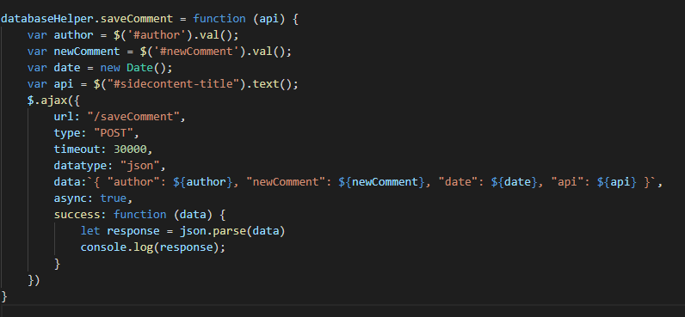
I used jquery selectors to access the element Id’s required to populate the final comment and saved them to clear useable variables. For the date variable, I used the function new Date to populate the data with the user’s time at input. I then set the data in the ajax request to the variables previously assigned and used type ‘POST’ as I would be saving the contents of the input into a local database in a separate function. This would maintain single responsibility of each function, rather than putting them into one function. Finally, I assigned the response to the parsed data and console logged the response to ensure the data was formatted as expected.

Next, on the submit button I added a ‘.click’ event listener (fig 16) onto the submit button so that when it was pressed this function would be called. This was placed inside the application.init file, so that it would be globally available whilst the program was running.
Fig.16 Event listener
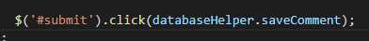

Now that the data was ready to be passed to the database in the vistechture.go file I created new functions to format the data and handle the database insert.

I began by creating a ‘struct’ for the comment which I encapsulated in the ‘main’ function (fig 17). This would provide a common place for all the separate variables that I needed to be grouped together; thus, enabling them to be easily accessed later in the code. This also aligned with Bgl groups best coding practices as this comment struct would be needed in several functions in the future, so making it a global would prevent repetition.
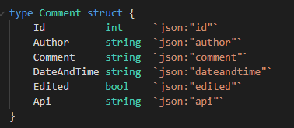
Fig.17: Comment Struct

I next created the function in the database controller which would accept the data and use an SQL insert to push the comment into the local database (fig 18). Again, creating this in a separate function would support SOLID principles and ensure that the code remained clear and readable for future reference.
Fig.18: Empty function for saving comments
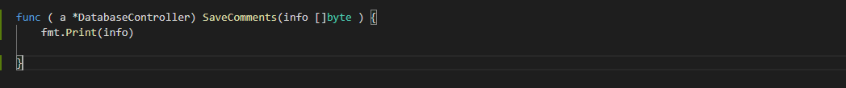
In vistechture.saveComments the function received the output from the http request and parsed the form into as an array byte type(fig 19), so that the data could be saved in a key/ value pair.
Fig.19: saveComments function with for loop
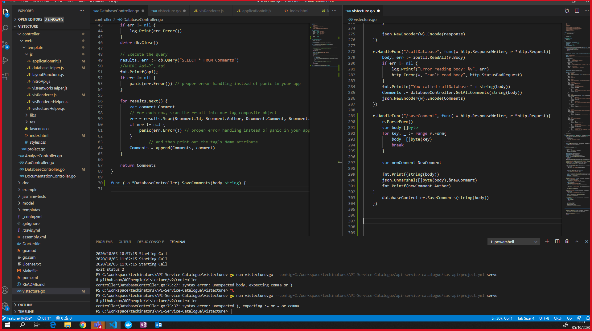

I decided to use a for loop to iterate over the body array. This would meet my coding requirements as it would iterate over each key and separately format it, ensuring all parts of the body were looped over. Each key from the body was extracted using a for loop and pushed back into the body separately so that it was in the correct format ready to be pushed into the database.
Finally, I passed the result of this into the databaseController.SaveComments function and began working on it (fig 20).
Fig.20: Passing the body into databaseController.SaveComments
Within the databaseController.SaveComments this array byte was then unmarshalled (parsed) and mapped to the existing comment struct. During this part, there were some problems with the unMarshalling not outputting the data in the correct format. I de-bugged it by using printF and outputting the results of the unMarshalling. I kept receiving the entire json object back, so I spent some time testing to see where the problem was.

I attempted to use stringify (fig 22, next page) on the body, and on the individual variables to try and present them in a string instead of the entire json object and I also used a for loop to iterate over key value pair and print out each part of the body, to no avail. The result of this debugging was that the data was getting confused by the use of the comment struct, which was also used elsewhere in programme. I fixed the issue by creating a second struct to use and labelled it ‘newComment’ and referencing that within my saveComments function (fig 21). This ensured clarity and single responsibility, and when the program was next ran the data was in the correct format (fig 22, 23).
Fig.21 Creating NewComment struct
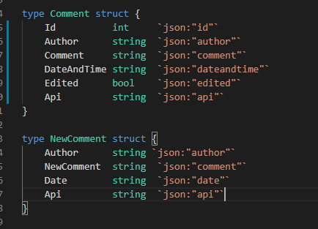
Fig.22: Using stringify and printF
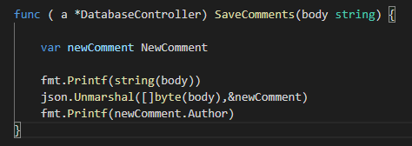
Fig.23: PrintF results after correct formatting
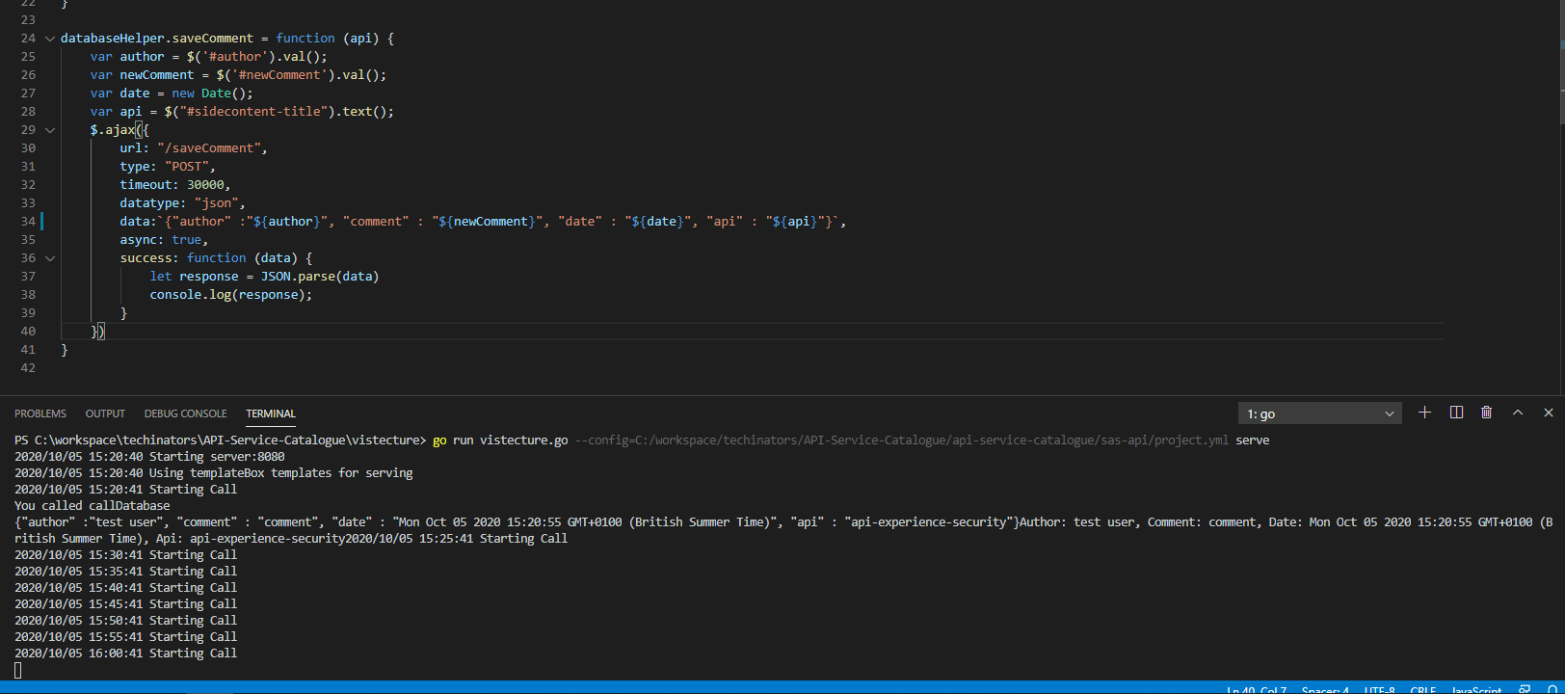

My next task was to initiate the SQL query to the local database, thus storing the comment. For this I began by setting the database connection string:
Fig.24: Open SQL connection string
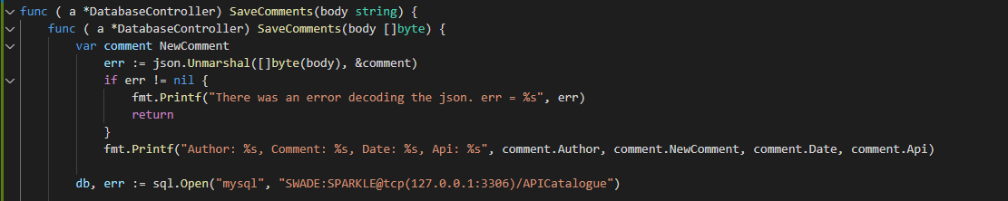
This was pointed to my local database, and would need to be changed upon deployment to point to the live version. Next, I created error handling that would send an error report if the connection string failed (fig 26).
Fig.25 On error example
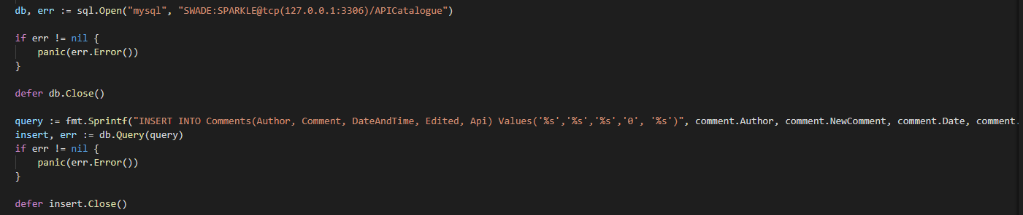
Here I used an if statement to validate that there were no errors encountered. The use of the if statement facilitated this check well and was the best approach to handling potential behaviour due to it executing if a particular defined condition was met (in this case if an error occurred). I included a one-line check that completed an error log if it found one.
If there was no error I needed to add the new comment into my local SQL database using a SQL statement. For this I chose to use ‘insert into’ so that I could populate just the columns I wanted to use, ignoring the others rather than just passing in all data each time. I also used placeholders, except for the Boolean ‘edited’ which was hard coded as a 0, due to this feature being out of scope for the current ticket.

I submitted this SQL query, and received an error message revealing that the date format did not match that of the database. The output indicated I was receiving a full date and time down to seconds, whereas the database need the format: YYYY-MM-DD HH:MM:SS.
I decided to format the date immediately on the initial database.saveComment function before any further formatting occurred to the function (fig 26).

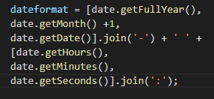
Fig.26 Formatting the date correctly

The result of this function was assigned to the date variable and the results tested by using printF later in the program. When the manual test showed the date in the correct format I pushed my work to the bitbucket repository associated with this work, as many changes had occurred. The process for version control in my company required me to push my code to a repository associated with the feature I was developing. At the beginning of the work period I had created a branch to work on, which was a direct copy of master. I worked off this branch pushing my code regularly adding meaningful commit messages. Working off a branch ensured that the live version of the Api catalogue was not effected by my work. As per my company’s standards I did not have permission to push to master until after a pull request had been reviewed and completed by a senior member of my team.

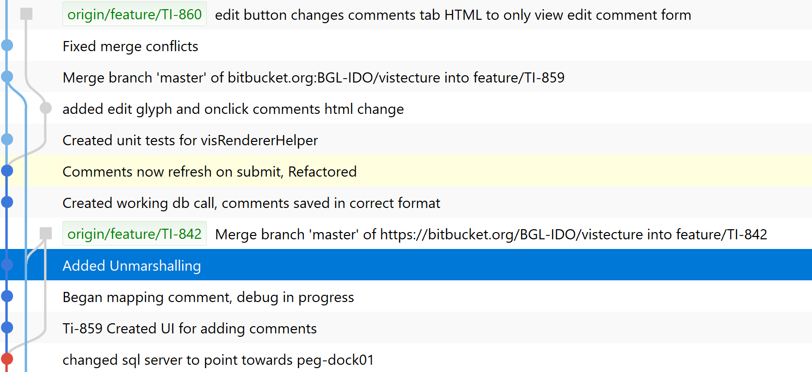
Fig.27 Using versioning

At this point I had functioning code that should allow a customer to enter a comment and have it stored on the local database. I verified this by entering text into the field, pressing submit then going to phpMyAdmin and checking my database contained the information required. The final step for the backend code to work was for the view to be updated and the comment read from the database via:

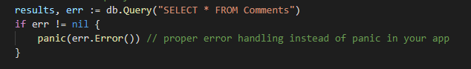
Fig.28 SQL Select use.

Which was included in the view comments function.
The outcome of this section of work was a working backend code which successfully linked to the front end created in the first part. I spent time debugging and manually testing my code to ensure the data was in the correct format to be entered into the database. I encountered several bugs simply because I hadn’t double checked the datatype required, for example I initially presumed ‘edited’ would be a Boolean based on its declared type and would require ‘false’ it was only after the program threw an error and time was spent console logging everything that I realised it required a ‘0’ or ‘1’ instead.
As stated with this stage of development complete the initial user story was sufficiently met, users could now successfully add a comment and view the comment with their name, date and comment on specific Api views. Using Ajax ensured everything was updated asynchronously, which ensured the feature remained responsive.

Deployment and Testing Phase
The final steps in code development in my work place is to thoroughly test any work completed, receive code reviews through a pull request and then have a senior tech lead complete the pull request thus merging work into the master version.
The final part of this project was to fully test the work completed, to ensure that the user cases were completely met. Secondly following standard coding practice in my company, I would need to complete a pull request on bitbucket and have a code review.

After pushing the final section of code to the repo I began writing unit tests into the program. For this is used Jasmine. Due to the nature of the Api catalogue being partly created by an outside organisation there was a limited number of functions that could be directly tested. I highlighted two important functions that directly linked to the user requirements. I decided to test whether the comment was rendered correctly on the page, as each comment should be created dynamically. I also tested that the comment couldn’t get posted onto the incorrect API view.

I began by importing the jasmine standalone into my project and running it to ensure it was setup correctly. When the page showed green tests, I began by creating visRendererHelper.spec. As the name suggests, the functions contained within visRendererHelper’s correctly render the page according to what data was contained.

In the spec file, I created a comments class with the same attributes as the comment struct.
Fig.29 Spec Comment class

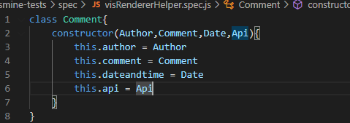

And created an expect output string that exactly matched the HTML/CSS that would be outputted for each individual comment.
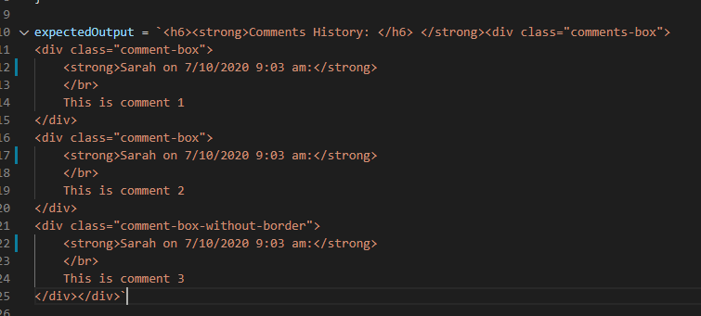
Fig.30 Setting expected output
Next the expected output was trimmed and added to an array of comments so it could be iterated over in the test, so these could be used for multiple tests this was placed in global scope.
Fig.31 comments array
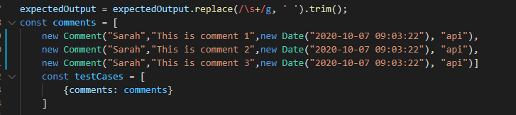
I then created the first unit test to test the getCommentsTable function; and described the scenario for which I was testing for, in this case that the table is created to hold the comments and that it has the correct html.
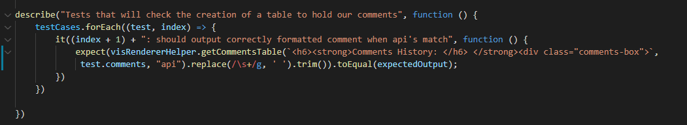
Fig.32 Unit test describe

I used a forEach loop within the test to test each comment within the comments array and ensure that the comments table did indeed format correctly. This was essential to test, as if this getCommentsTable failed to do this, the page would become an unreadable mess. Within this test I also ensure that not only did it render correctly, that the comment only appeared if it’s stored api matched the api of which the user was on. This was to ensure that one of the main user cases was met, that comments were always posted onto the correct api.

My second test tested the opposite, that if the api’s did not match then the comment would not be added.
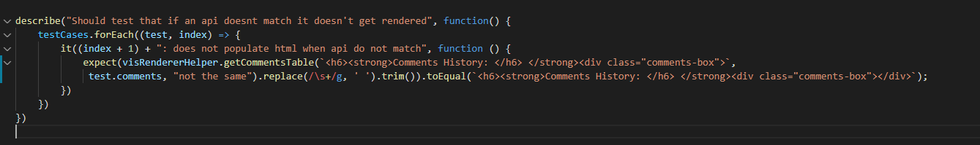
Fig.33 Testing incorrect information doesn’t render

Again, I used a forEach loop to check comment from the comments array, but instead of passing in an Api of the same name I changed it to look for ‘not the same’ and to. I selected to use a forEach loop so that however many test cases there were, the code would always run until it had been over all of them. This means in the future I could add more test cases without breaking the code. It was also the most simple approach, for example if I had used a switch statement it would have been lengthy and more difficult for other developers to read later on.
These tests both worked as planned.
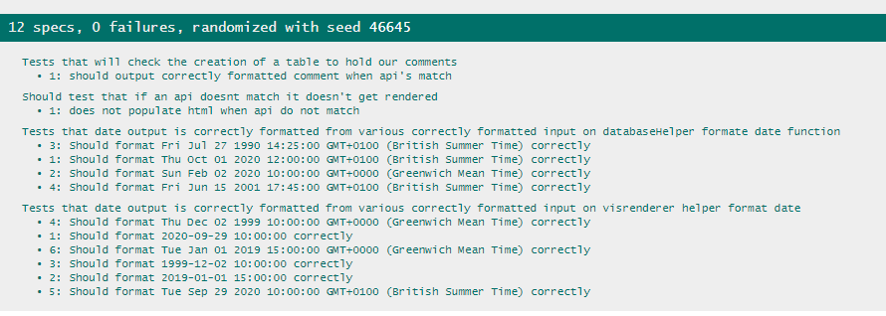
Fig.34 Passing Tests

With the tests showing green, I pushed my work to the Bitckbucket repository and created a pull request. This is standard policy in my company before a branch is merged into master.
My work was reviewed by two other developers, and the feedback put line by line (fig 35).
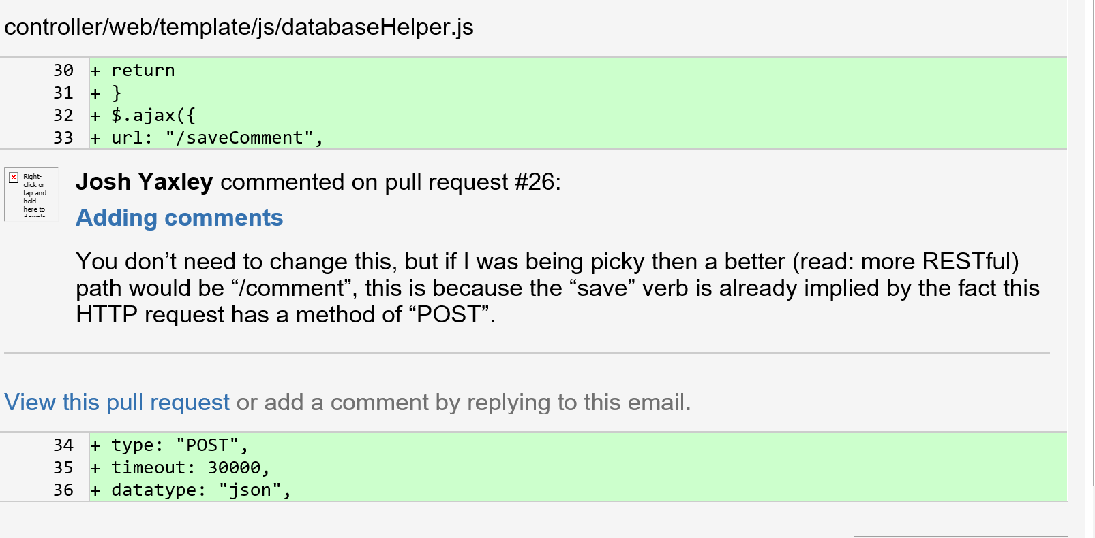
Fig.35 Code Review
The pull request provided invaluable feedback and enabled me to refactor my code to improve it. In accordance with the above feedback I altered the names of some of the functions to be more ‘RESTful’. Instead of ‘databaseHelper.saveComment’ I updated it to ‘.addComment’ which was a lot clearer. In addition to this I decided to move out the ‘.dateFormat’ function from within the Ajax request, keeping in line with S.O.L.I.D principles and generally just increasing readability (fig 35).
Fig. 35 formatDate to its own function
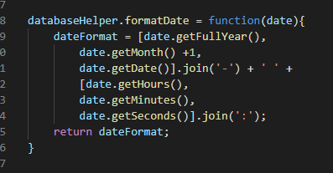

A second example of the excellent feedback I received was my reviewer pointing out that the connection string I’d set up for the database was hard coded. My reviewer recommended abstracting it out into an environmental variable.
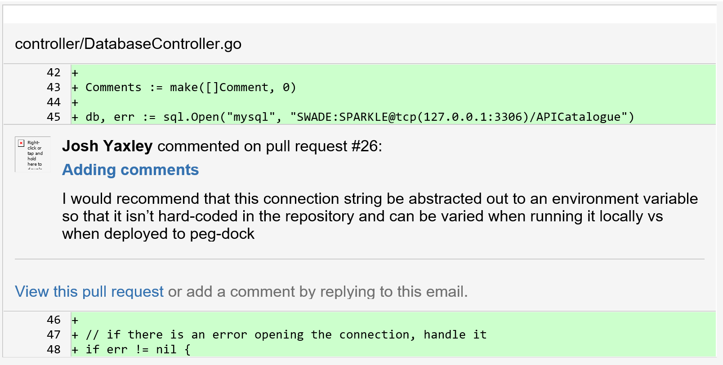
Fig. 36 Code Review Sample

I acted upon this and set up an environmental setting on my machine called ‘DATABASE_CONNECTION_STRING’ and used Getenv to access the variable. This would require a one-time setup when the feature goes live and would be much easier to maintain going forward (fig 37).
Fig. 37: Using environmental variable to set the connection string
Once I had finished refactoring my code and updated suggestions highlighted in my code review the last stage of the process was to ask a senior technical lead to accept the pull request and merge it into the live version of the Api Catalogue.

Conclusion

During this development period, I worked as part of a team to deliver an adding comments feature that aimed to meet the user case outlined by a product owner.
My result was a tidy user interface that enabled the user to input a name and comment into separate fields and press a submit button to send the data to a local database. The user interface conformed with the styling previously created. This did cause me some small problems when creating the html/css as some of the inherited styles did not work well with what I needed the comments box to do, such as when the submit button floated to the top of the container instead of sitting bottom right. I would have preferred not to have hard coded the size of the overall comments tab, however when I attempted to use the same settings at the other tabs that enlarged dynamically I struggled to get all the containers to sit correctly. Thus, I hard coded the size of that single tab. Whilst this is not a major problem, it will be an inconvenience if the comments tab gets changed in the future as it will not resize itself. If I had had time I would have preferred to spend time making a more flexible solution, but in the end, I had to prioritise delivering a working product in my sprint timeframe.
Otherwise I feel the user interface development went smoothly and that receiving regular feedback from the product owner ensured the deliverable was good quality and met the needs of the user.

I found the back-end development far more challenging, working with golang and javascript was a new experience for me which added some challenges from the outset. Again, the outcome of this stage of development was specifically tailored to meet the outlined requirements, and this is where the refinement I completed during the initial design phase truly supported ensuring the outcome matched with what the product owner originally outlined. By creating bespoke tickets for each user story this enables clear goals for every part of development and guided what I worked on in sequence.
They key to the back-end development was receiving a code review from my teammates. The feedback I received here made a huge contribution to the end result’s quality, helping steer me to best practice approaches. The feedback helped me maintain single responsibility principle and pointed out typo’s. For instance, where I had not used strict (===) comparison operators in my JavaScript code where I should have, which could have caused bugs upon deployment. After the code review, I also went through my code with a peer and together we refactored my work, removing the AJAX call and using fetch instead, an approach that greatly simplifies the code.

I felt that I developed my coding skills tremendously during this feature’s development. In reflection, there are several area’s I would have done differently from the onset now that I have more experience, such as conforming to single responsibility from the onset. That being said, the final product met the user requirements and satisfied the product owner. The impact on the business from this piece of work was a useful tool that supported out of hours troubleshooting, and enabling users to comment on Api status’s and resolutions that may have been found.

Deleting a Comment

Once my work was completed on ‘adding a comment’. I was able to begin working on the next ticket for the api catalogue. As mentioned previously I identified a user story for deleting comments once they had been made which would improve the entire comments feature.
The requirements for this work were:
- user should be able to choose a particular comment
- user can delete this comment from the view
- the comment should be removed from the database

I used the user stories to create a jira ticket with the acceptance criteria (fig 38).
Fig. 38: Using the user stories to create a jira ticket
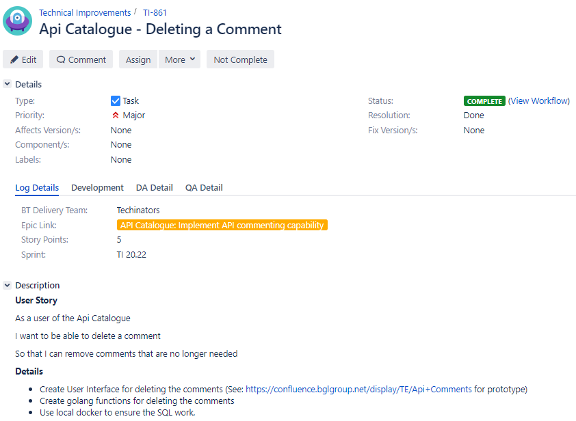

Based upon the user stories I created a basic design that would match Below you can see an activity diagram demonstrating how a user might interact with both the adding and deleting comments features and the steps they would perform to achieve the end goal of adding or deleting comments (fig 39).
Fig. 39: User activity diagram
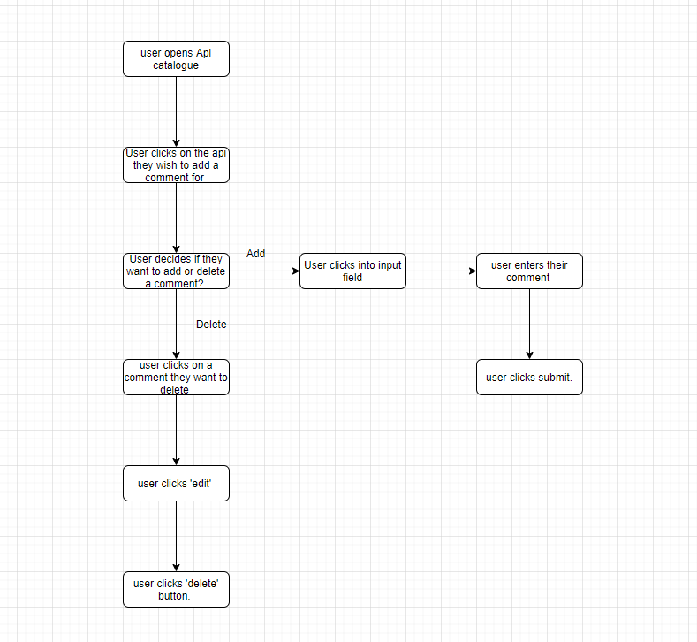

During the design phase, as you can see from the activity diagram, it was decided the delete comment feature would come under the ‘edit’ view (fig 40).

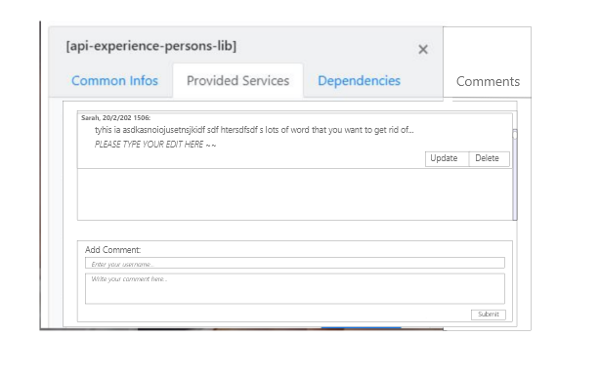
Fig. 40: Prototype delete comment design within the ‘edit comment ‘ view.
The edit comment feature was implemented by another member of my team, so I would be able to simply insert the delete button into the view previously created.

Deleting a comment development

Once again, I began with the html/ CSS front end code. Using the existing ‘edit comment’ html I began by adding a bootstrap button. This was a different process to ‘adding a comment’ as the delete button would need to be rendered dynamically instead of just statically appearing on a page. The code for the front end therefore would be included in’visRendererHelper.js’. As the name suggests functions in this file were responsible for rendering each view depending on user behaviour.

I added the bootstrap button into the ‘edit comment’ function (fig 41). This ensured that the button would only appear when the user clicks ‘edit’, as per the design.
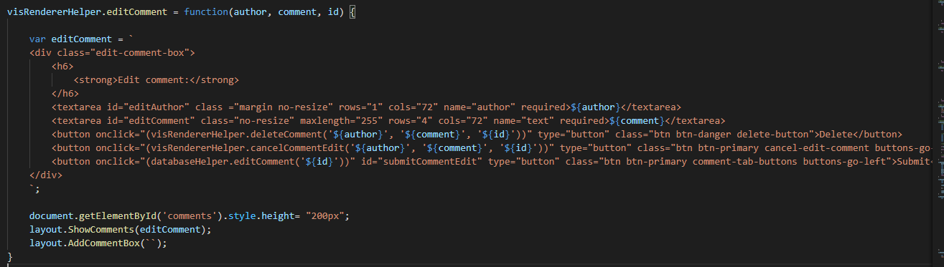
Fig. 41: HTML/ CSS for the delete button
I then created a named function expression called ‘deleteComment’ to handle the deleting of the comment HTML. How the visRenderer functions work, is the html required is defined within separate string based variables. These variables are then used in the layout.js functions. As you can see from figure 42 this is how I created the delete comment HTML/CSS. I chose to create a separate function to handle this in order keep to the single responsibility principle.
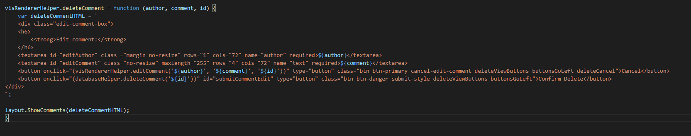
Fig. 42: Delete comment front end function

I passed in the author, comment and comment id and outlined the required html/css required to make the bootstrap button render in the correct position. The textarea used the same setup as the previous views and utilized an onclick event to hook in other required functions. I used an inline onclick event so that everything referring to the specific button was in one place and to ensure there was no confusion about what event would trigger “deleteComment”. The alternative would be by using ‘get element by id’ or such. This would have had to be in a separate place to the deleteCommentHTML, which would not have been as tidy.

With the front-end view created and the function that would load the comment with the delete option setup, my final task was to create the function responsible for removing the comment from the database and thus meeting the original user stories. Once the specific comment was removed from the database, the view would asynchronously update and the comment would be removed from the users view.
I created the deleteComment function within the databaseHelper, with the other database functions. The format was similar to when I created the ‘adding comments’ logic, except this time I would be passing in the comment and using a DELETE FROM SQL statement to remove the comment with a corresponding id from the database (fig 43).
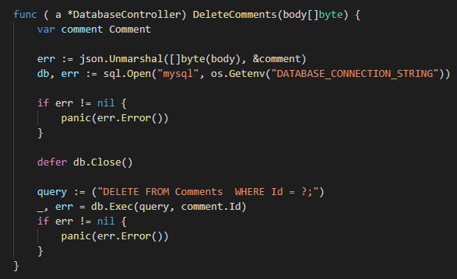
Fig. 43: database DeleteComments

Again, first I unmarshal’d the body and used an if statement to evaluate whether the connection was successful. I used an if statement as I was only checking against one condition.
Next I used defer for db.close. I chose to use defer to ensure that the program ran asynchronously. Defer scripts will only run when the parsing is complete which will assist with overall efficiency.

With this completed I manually tested the work done to ensure that comments were being correctly deleted, which they were. See figure 44 for the final product.
Fig. 44: Final Product
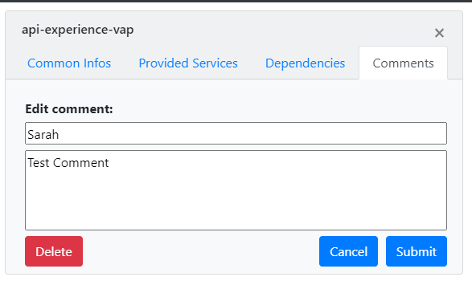

Conclusion

This concluded the work I completed for the ‘deleting comments’ ticket. The final product sufficiently met the user stories outlined during the inception and allowed users to delete a selected comment. This piece of development felt a lot smaller than the initial adding comment’s partly due to the fact I could piggyback most of the layout functions from the editing comment work that was completed. I also understood the flow of the project a lot better the second time I worked on it, which helped a lot in understanding what components I would need to create and where. I was also able to incorporate some of the learning from the adding comment’s, through implementing the ‘defer’ logic, as per my previous pull request feedback from adding comments.
One of the parts I would have liked to have a chance to refactor would be the visRendererHelper HTML string. Many parts of this string were long and repetitive and I feel that I could refactor this into one string used by both editing comments and delete.

